**Software development ecommerse application with images**

**Crafting a Robust E-commerce Application: A Visual Guide**

**Understanding the Core Components**

An e-commerce application, at its heart, is a complex system that involves multiple interconnected components. Here's a simplified breakdown:

[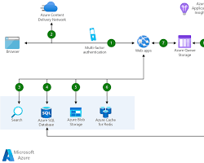Opens in a new window[](https://learn.microsoft.com/en-us/azure/architecture/web-apps/idea/scalable-ecommerce-web-app)learn.microsoft.com](https://learn.microsoft.com/en-us/azure/architecture/web-apps/idea/scalable-ecommerce-web-app)

Ecommerce Application Architecture Diagram

* **Frontend:** The user-facing part of the application, responsible for the visual interface and user interactions.
* **Backend:** The server-side logic that handles data processing, database interactions, and business rules.
* **Database:** Stores product information, user data, orders, and other relevant data.
* **Payment Gateway:** Processes online payments securely.
* **Shipping and Logistics:** Manages order fulfillment, shipping, and tracking.

**Key Features and Functionalities**

A successful e-commerce application should offer a seamless shopping experience. Here are some essential features:

* **Product Catalog:**

[Opens in a new window[](https://dribbble.com/tags/catalog-page)dribbble.com](https://dribbble.com/tags/catalog-page)

Product Catalog Page

* + Clear product descriptions
  + High-quality images
  + Customizable filters and search
  + Product reviews and ratings
* **Shopping Cart:**

[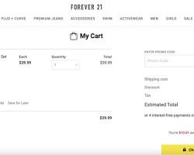Opens in a new window[](https://www.optimonk.com/10-impressive-ecommerce-shopping-cart-design-examples-online/)www.optimonk.com](https://www.optimonk.com/10-impressive-ecommerce-shopping-cart-design-examples-online/)

Shopping Cart Page

* + Add/remove items
  + Calculate total price and taxes
  + Apply discounts and coupons
* **Checkout Process:**

[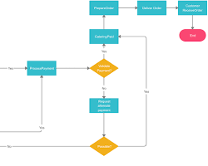Opens in a new window[](https://creately.com/diagram/example/z9Ohq5eKMBz/customer-order-process-flowchart)creately.com](https://creately.com/diagram/example/z9Ohq5eKMBz/customer-order-process-flowchart)

Checkout Process Flowchart

* + Secure payment gateway integration
  + Shipping address and billing information
  + Order summary and confirmation
* **User Accounts:**

[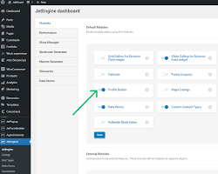Opens in a new window[](https://crocoblock.com/knowledge-base/jetengine/creating-user-account-page/)crocoblock.com](https://crocoblock.com/knowledge-base/jetengine/creating-user-account-page/)

User Account Dashboard

* + Account creation and login
  + Profile management
  + Order history
  + Wishlist
* **Admin Panel:**

[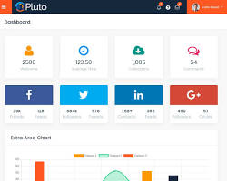Opens in a new window[](https://themewagon.com/themes/pluto-free-bootstrap-4-html5-admin-dashboard-template/)themewagon.com](https://themewagon.com/themes/pluto-free-bootstrap-4-html5-admin-dashboard-template/)

Admin Panel Dashboard

* + Product management
  + Order management
  + Customer management
  + Analytics and reporting

**Technology Stack**

The choice of technology stack depends on various factors like project scale, performance requirements, and team expertise. Here's a popular tech stack:

* **Frontend:** React, Angular, or Vue.js
* **Backend:** Node.js, Python (Django or Flask), or Ruby on Rails
* **Database:** PostgreSQL, MySQL, or MongoDB
* **Cloud Platform:** AWS, Azure, or Google Cloud Platform
* **Payment Gateway:** Stripe, PayPal, or Braintree

**Design Considerations**

A well-designed e-commerce application can significantly impact user experience and sales. Key design principles include:

* **User-Centric Design:** Focus on the user's needs and preferences.
* **Responsive Design:** Ensure the application works seamlessly on various devices.
* **Fast Loading Times:** Optimize images and minimize HTTP requests.
* **Secure Transactions:** Implement robust security measures to protect user data.
* **Clear Call-to-Actions:** Guide users towards desired actions.

**Additional Tips**

* **Test Thoroughly:** Conduct rigorous testing to identify and fix bugs.
* **Optimize for SEO:** Improve search engine visibility with SEO best practices.
* **Leverage Social Media:** Promote your products and engage with customers.
* **Offer Excellent Customer Support:** Provide timely and helpful assistance.
* **Stay Updated with E-commerce Trends:** Continuously adapt to industry changes.